Mobile Marketing Exercise – Instructions for Organizers
Introduction: Mobile apps and careers related to mobile are becoming increasingly important, relevant and lucrative as the industry grows. The mobile apps are expected to generate $25 billion in sales this year alone (Wall Street Journal, March 2013).
However, with more than a billion apps available for download for smartphones, companies need people who can help them stand out in a crowded market. They need people who understand where to target advertising, how to attract downloads and how to acquire users that stick around (and ideally pay money).
This exercise is aimed at getting teens to think about where they might place adverts for different mobile apps, in order to encourage the most relevant people to download their app – at the best price.
Instructions – Full
- Each individual or team is assigned an application from the list below. This application includes some information about how they make money and who they are trying to reach.
- They are given start up investment of £100,000. Their task is to allocate the £100,000 across the advertising channels in a way that helps them reach the right people at the best price.
- Once the teams have allocated their budget, they must explain to the rest of the group who they are targeting and why.
- The organisers then calculate how many users each time acquired, and the number of users in the correct demographics. The team that got the most users in the correct demographic gets acknowledged at the end of round 1 and each team gets £4.99 (the value per user across all apps) times their acquired user base of the correct demographic (plus any remaining money from the original £100,000) for round two.
- There are some bonuses and penalties that teams can earn in each round, to better help them understand the value of placing advertising in the right location. They are as follows:
  - If the team promoting 23snaps spends the most money on CafeMom.com, they get an additional 10,000 downloads because it’s a chat site for mums so they all talk to each other about the app. However if they spend the most money on Facebook, they only get £2.49 per user from that channel because people using Facebook only want things that are free.
  - If the team promoting Paprika spends the most money on Facebook, they get an additional 10,000 downloads because people share the app with their friends. However if they spend the most on Allrecpies.com, they only get half as many users because everyone on that site already has a way to save recipies.
  - If the team promoting Uber spends the most money on any channel that doesn’t target Londoners, they only get half as many signups because the service only works in London. However if they spend the most on Marketwatch.com, they get £7.50 per user instead of £4.99 because the business professionals use the private driver service more often.
  - If the team promoting Zombies, Run spends moneys on Gamers AND Runners on Facebook, they get an extra 10,000 downloads because the adventure story part of the app appeals to the gamer demographic. However if they try to give out flyers at the London Marathon, they only get half as many signups because the majority of the people there aren’t runners, just fans.
  - If ANY team tries to put a budget of less than £10,000 to any magazine, or to Tube adverts, the prices is too low, their budget is returned and they can’t spend it until the next round.
- The teams then get to reallocate their budgets, including all bonuses, and the organiser then calculates which team has acquired the most users of the correct demographic.
Instructions – Lite
- Same start as before except, each team gets £100,000 split into a £50,000 budget, a £30,000 budget and a £20,000 budget which can each be allocated to one of the advertising channels.
- Once the teams have spent their budgets, they must explain who they are targeting and why.

- There are some bonuses and penalties that teams can earn, to better help them understand the value of placing advertising in the right location. They are as follows:
  - If the team promoting 23snaps spends the most money on CafeMom.com, they get an additional 10,000 downloads because it’s a chat site for mums so they all talk to each other about the app. However if they spend the most money on Facebook, they only get £2.49 per user from that channel because people using Facebook only want things that are free.
  - If the team promoting Paprika spends the most money on Facebook, they get an additional 10,000 downloads because people share the app with their friends. However if they spend the most on Allrecpies.com, they only get half as many users because everyone on that site already has a way to save recipes.
  - If the team promoting Uber spends the most money on any channel that doesn’t target Londoners, they only get half as many signups because the service only works in London. However if they spend the most on Marketwatch.com, they get £7.50 per user instead of £4.99 because the business professionals use the private driver service more often.
  - If the team promoting Zombies, Run spends moneys on Gamers AND Runners on Facebook, they get an extra 10,000 downloads because the adventure story part of the app appeals to the gamer demographic. However if they try to give out flyers at the London Marathon, they only get half as many signups because the majority of the people there aren’t runners, just fans.
- The organisers then calculate how many users each time acquired, and the number of users in the correct demographics. The team that got the most users in the correct demographic gets acknowledged
Channel  (The place where you’re doing your marketing) | Demographic  (The type of people who see your marketing) | Reach  (How many people see your marketing) | Cost per Acquisition  (How much it costs to get one sign up) | Your Spend  (How much do you want to spend on this channel?)
Magazines
Women’s Health | UK women between 34 and 65 who are interested in staying healthy. | 100,000 | £20
Men’s Health | UK Men between 34 and 65 who are interested in staying healthy. | 110,000 | £15
Cosmopolitan | UK women between 17 and 30 who are interested in fashion, fitness and celebrity gossip. | 220,000 | £30
Facebook
Parents | All English-speaking parents of under 3s | 2,000,000 | £2
Cooks | Anyone who has ‘Liked’ Cooking | 40,000,000 | £1
Londoners | Anyone living in London | 6,000,000 | £7
Runners | Anyone who ‘Liked’ running | 20,000,000 | £2
Gamers | Anyone who plays games on Facebook | 50,000,000 | £1
Websites
Allrecipies.com | Women 34+ who like cooking. This site allows them to save their recipes. | 4,000,000 | £5
MarketWatch.com | Men 24 – 64 who are interested in stocks and finance. | 3,500,000 | £10
CafeMom.com | Mothers who want to chat with other mums online. | 4,000,000 | £10
MyFitnessPal.com | Women who want to keep fit. | 5,000,000 | £7
Boards & Flyers
Bus Stop Adverts | London commuters who take the bus. | 15,000,000 | £40
Flyers outside tube stations | London commuters who take the tube. | 10,000,000 | £50
Flyers at the London Marathon | People who are runners, or friends with runners. | 1,500,000 | £8
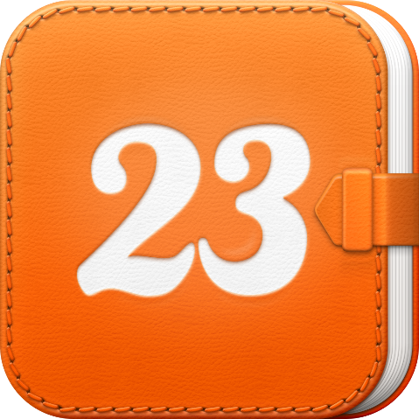
23snaps
23snaps is a free app that lets parents save photos, videos and updates of their children to a private online journal, then securely share those updates with family and close friends.

Cost: Free
Demographics: Mums and dads of kids aged 0 – 3, located anywhere in the world.
Available on: iPhone, iPad, Android phones, Windows 8 Surface, online
How the app makes money: The free users can pay to order photo prints and photo books from the app. On average, they expect to earn £4.99 per user in the first month.

Paprika
Paprika is a recipe organiser that makes it easy for cooks to save their favourite recipes, find new recipes, share recipes with friends, and follow recipe instructions while in the kitchen.

Cost: £4.99
Demographics: People who like cooking and regularly cook for themselves, all over the world.
Available on: iPhone and iPad.
How the app makes money: By charging £4.99 for someone to download the app.

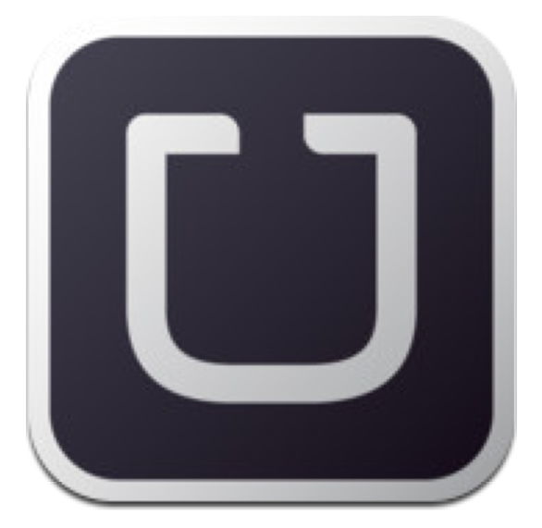
Uber
Travel in style! Uber is a new breed of taxi service. When you need to get from one place to another, simply load the Uber app and Uber will send a private driver in a sleek black town car to take you to your destination.

Cost: Free to download
Demographics: Business professionals in London
Available on: iPhone, iPad, Android phones
How the app makes money: Once the user downloads the app for free, they need to pay to use the private drivers. On average, they expect to earn £4.99 per user in the first month.

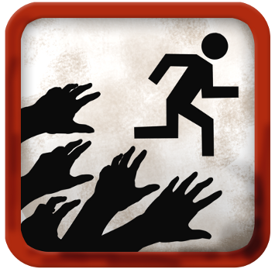
Zombies, Run!
Zombies, Run! Is an exciting new fitness and running app and an ultra-immersive running game and audio adventure, where the story of how you’re trying to escape zombies and save your town from zombie attack. The app syncs with your phone’s GPS so that the story really reacts to how fast you run!

Cost: £4.99
Demographics: People who like running, stories and adventure games anywhere in the world.
Available on: iPhone and Android.
How the app makes money: By charging £4.99 for someone to download the app.

